VLAN:

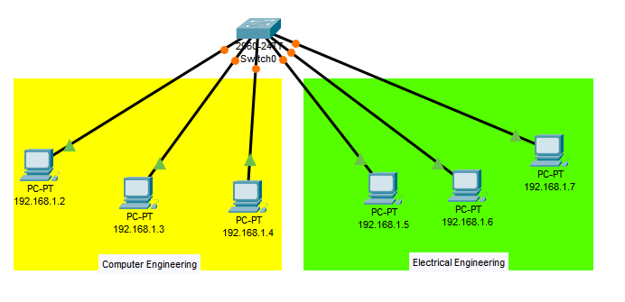

**Commands:**

* **switch:**

en

config t

hostname sw1

vlan 10

name com

vlan 20

name ele

int range f0/1-3

switchport access vlan 10

switchport mode access

int range f0/4-6

switchport access vlan 20

switchport mode access

show vlan br

wr

Inter-VLAN:

Legacy Inter-VLAN Routing:

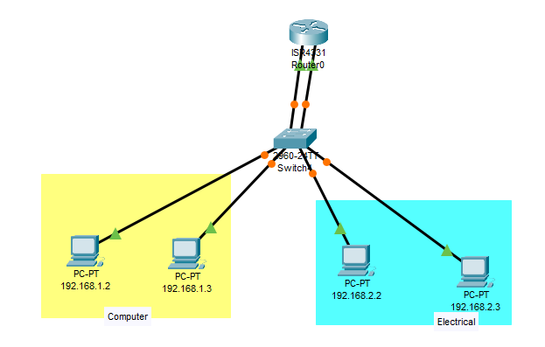

**Commands:**

* **switch:**

en

config t

hostname sw1

vlan 10

name com

vlan 20

name ele

int range f0/3

switchport access vlan 10

switchport mode access

int range f0/4

switchport access vlan 10

switchport mode access

int range f0/5

switchport access vlan 20

switchport mode access

int range f0/6

switchport access vlan 20

switchport mode access

int range f0/1

switchport access vlan 10

switchport mode access

int range f0/2

switchport access vlan 20

switchport mode access

sh vlan br

wr

* **router:**

en

config t

hostname R1

int g0/0/0

ip add 192.168.1.1 255.255.255.0

no sh

int g0/0/1

ip add 192.168.2.1 255.255.255.0

no sh

sh ip int br

wr

Router-on-a-Stick Inter-VLAN Routing: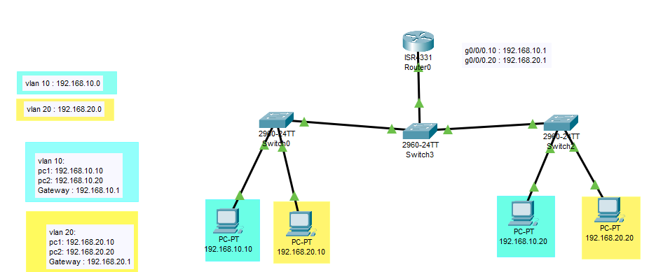

* **switch0:**

en

config t

vlan 10

name LAN10

vlan 20

name LAN20

int fa0/1

switchport mode access

switchport access vlan 10

int fa0/2

switchport mode access

switchport access vlan 20

wr

sh int br

* **switch2:**

en

config t

vlan 10

name LAN10

vlan 20

name LAN20

int fa0/1

switchport mode access

switchport access vlan 10

int fa0/2

switchport mode access

switchport access vlan 20

wr

sh int br

* **switch3:**

en

config t

vlan 10

name LAN10

vlan 20

name LAN20

int fa0/1

switchport mode trunk

int fa0/2

switchport mode trunk

show interface trunk

int g0/1

swithport mode trunk

show int trunk

* **Router:**

en

config t

int g0/0/0.10

encapsulation dot1Q 10

ip add 192.168.10.1 255.255.255.0

int g0/0/0.20

encapsulation dot1Q 20

ip add 192.168.20.1 255.255.255.0

int g0/0/0

no sh

Inter VLAN Routing on Multilayer/Layer 3 Switch:

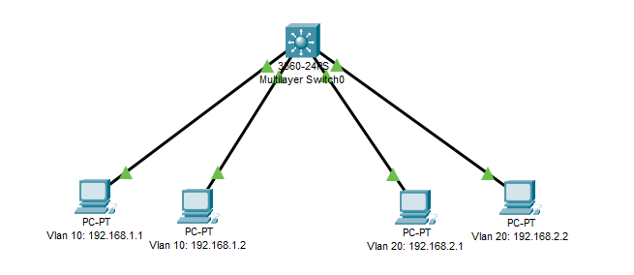

* **Multi-layer switch:**

en

config t

vlan 10

name LAN10

vlan 20

name LAN20

int f0/1

switchport mode access

switchport access vlan 10

ex

int f0/2

switchport mode access

switchport access vlan 10

ex

int f0/3

switchport mode access

switchport access vlan 20

ex

int f0/4

switchport mode access

switchport access vlan 20

ex

ex

sh vlan br

int vlan 10

ip add 192.168.1.10 255.255.255.0 (default gateway of vlan 10)

no sh

ex

int vlan 20

ip add 192.168.2.10 255.255.255. 0 (default gateway of vlan 20)

no sh

ex

ip routing

Build network using two router:

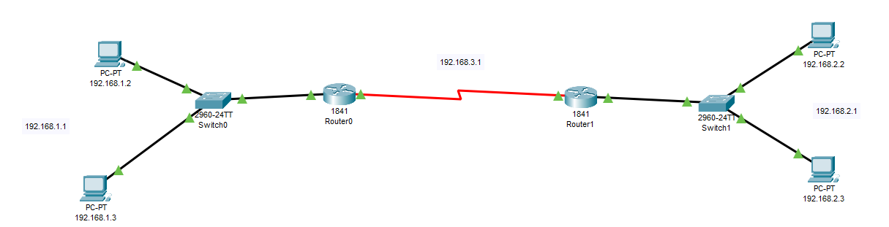

* **Router 1:**

en

config t

int f0/0

ip add 192.168.1.1 255.255.255.0

no sh

ex

int se0/1/0

ip add 192.168.3.1 255.255.255.0

no sh

ex

ip route 0.0.0.0 0.0.0.0 se0/1/0

ex

* **Router 2:**

en

config t

int f0/0

ip add 192.168.2.1 255.255.255.0

no sh

ex

int se0/1/0

ip add 192.168.3.1 255.255.255.0

no sh

ex

ip route 0.0.0.0 0.0.0.0 se0/1/0

ex

Routing between different networks:

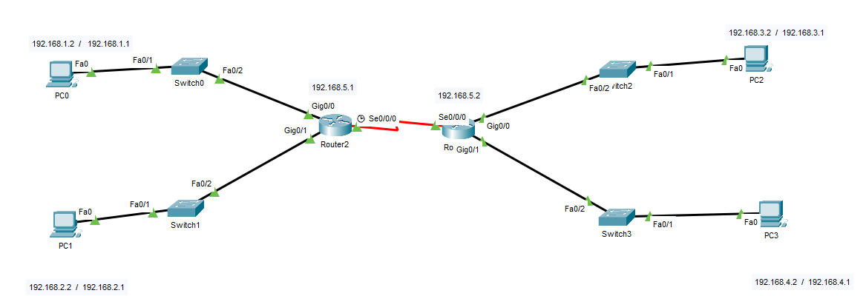

* **Router 2:**

int g0/0

ip add 192.168.1.1 255.255.255.0

no sh

ex

int g0/1

ip add 192.168.2.1 255.255.255.0

no sh

ex

int s0/0/0

clock rate 72000

ip add 192.168.5.1 255.255.255.0

no sh

ex

ip route 192.168.0.0 255.255.0.0 192.168.5.2

* **Router 3:**

int g0/0

ip add 192.168.3.1 255.255.255.0

no sh

ex

int g0/1

ip add 192.168.4.1 255.255.255.0

no sh

ex

int s0/0/0

ip add 192.168.5.2 255.255.255.0

no sh

ex

ip route 192.168.0.0 255.255.0.0 192.168.5.1

**STP-RSTP:**

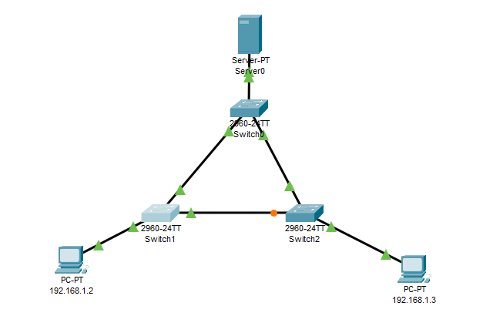

en

config t

show spanning tree

STP: to make root bridge : spanning-tree vlan 1 root primary

show spanning-tree

to create fault : int f0/1

sh

RSTP: spanning-tree mode rapid-pvst

end

copy running-config start-up running config

**Etherchannel:**

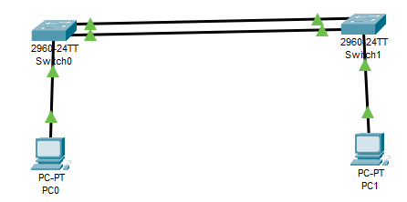

en

config t

interface range f0/1-2

channel-group 1 mode active

no sh

exit

interface port-channel 1

switchport mode trunk

end

* **show interfaces port-channel**
* **show ether channel summary**
* **show ether channel port-channel**
* **show interfaces etherchannel**

show run | begin interface port-channel

* **show ether channel summary**

**DHCP:**

* Router as a server:

r-1, s-2, pc-2

en

config t

int fa0/0

ip add 192.168.0.1 255.255.255.0

no sh

do write memory

ip dhcp pool net1

network 192.168.0.1 255.255.255.0

ex

int fa0/1

ip add 192.168.1.1 255.255.255.0

no sh

do write memory

ip dhcp pool net2

network 192.168.1.1 255.255.255.0

ex

* go to end device & select dhcp options to provide ip
* Router as a client:

1 r as server 1 r as client

Router as a server:

en

config t

int fa0/0

ip add 192.168.0.1 255.255.255.0

no sh

ex

ip dhcp pool net 1

network 192.168.0.1 255.255.255.0

ex

Router as a client:

en

config t

int f0/0

no sh

ip add dhcp

show ip int f0/0

**LAN PORT SECURITY:**

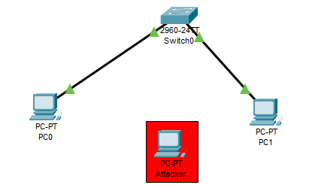

* Switch:

int range f0/2-3

switchport mode access

switchport port-security

switchport port-security mac-address sticky

switchport port-security maximum 1

switchport port-security violation shutdown

exit

* Check the connectivity of pcs by ping or sending massages.

show port-security

show mac address-table

* Add attacker in the network.

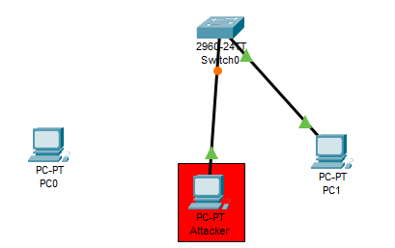

* try to do ping or message from attacker's PC.

Show ip int br

* now pc0 connects with switch 0.

int f0/2

shutdown

no shutdown

* try to do ping or message from pc1 to pc2.

**VLAN Security:**

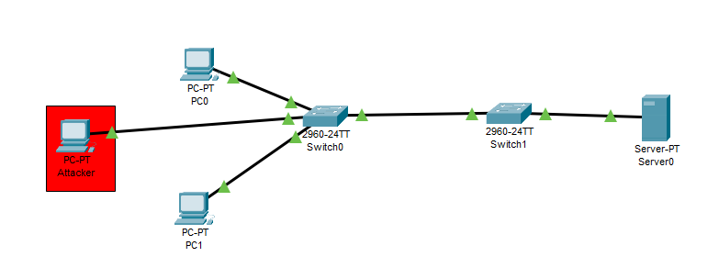

**Switch 0:**

en

conf t

vlan 10

name office

vlan 20

name blackhole

vlan 30

name management

vlan 40

name native

ex

ex

sh vlan br

int range f0/1-24

sw mo ac

sw no

int range f0/3-24

sw ac vlan 20

int range f0/1-2

sw ac vlan 10

int g0/2

sw mo ac

sw no

sw ac vlan 20

sh

int g0/1

sw mo tr

sw no

sw tr na vlan 40

ex

ex

sh vlan br

**Switch 1:**

en

conf t

int g0/1

sw mo tr

sw no

sw tr na vlan 40

**DHCP Snooping:**

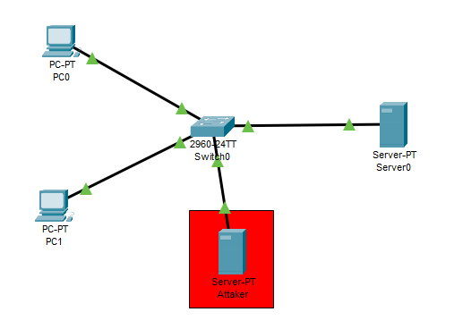

**server 0**, apply ip add 192.168.10.1 default gate way 192.168.10.10

Go to services, DHCP, configure address pool,

default gate way 192.168.10.10

starting ip 192.168.10.11 subnet mask 255.255.255.0

number of user 10

save

**pc0,** call dhcp request for ip and default gate way

**pc1**, call dhcp request for ip and default gate way

**Take attacker server**, apply ip add 192.168.10.2 default gate way 192.168.10.5

Go to services, DHCP, configure address pool,

default gate way 192.168.10.5

starting ip 192.168.10.6 subnet mask 255.255.255.0

number of user 10

**pc0,** call dhcp request for ip and default gate way

**pc1**, call dhcp request for ip and default gate way

**It takes attacker ip and default gate way**

**To prevent dhcp attack we can do snooping:**

**Switch,**

en

conf t

ip dhcp snooping

ip dhcp snooping vlan 1

ex

show ip dhcp snooping

**Verify,**

**pc0,** call dhcp request for ip and default gate way

**pc1**, call dhcp request for ip and default gate way

**It shows dhcp failed.**

**Now we makes original server port as a trust port,**

config t

int f0/3

ip dhcp snooping trust

show ip dhcp snooping

**Verify,**

**pc0,** call dhcp request for ip and default gate way

**pc1**, call dhcp request for ip and default gate way

**It doesn't take attacker ip and default gate way**

**we can secure our dhcp from attacker by using dhcp snooping.**

**Dynamic ARP Inspection:**

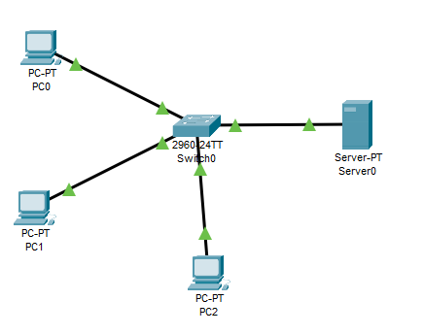

**Take pc0, pc1, switch and server.**

**server 0**, apply ip add 192.168.10.1

Go to services, DHCP, configure address pool,

starting ip 192.168.10.2 subnet mask 255.255.255.0

number of user 10

save

Connect all the devices.

**pc0,** call dhcp request for ip

**pc1**, call dhcp request for ip

**Switch:**

en

conf t

ip dhcp snooping

ip dhcp snooping vlan 1

int f0/3

ip dhcp snooping trust

ex

**Take Pc2, manually configure ip same as ip of pc0, and connect it with switch.**

**Do ping for verify the connectivity.**

**Switch:**

ip arp inspection vlan 1

int f0/3

ip arp inspection trust

ex

**Go to command prompt of pc2,**

arp -a

arp -d

Try to do ping, the attacker pc can't ping any authenticate devices.

**STP Mitigation:**

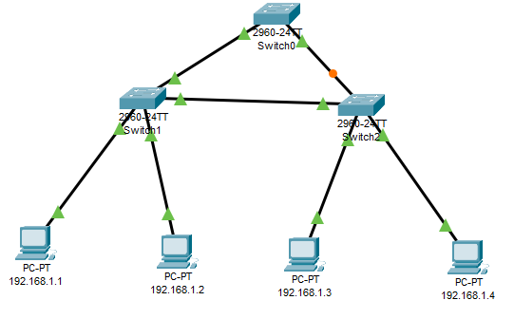

**Switch 0:**

en

config t

spanning-tree mode rapid-pvst

spanning-tree vlan 1 root primary

ex

show spanning-tree

**Switch 1 and Switch 2:**

en

config t

spanning-tree mode rapid-pvst

spanning-tree vlan 1 root secondary

int range f0/1-24

switchport mode access

spanning-tree portfast

spanning-tree bpduguard enable

**Wireless Network:**

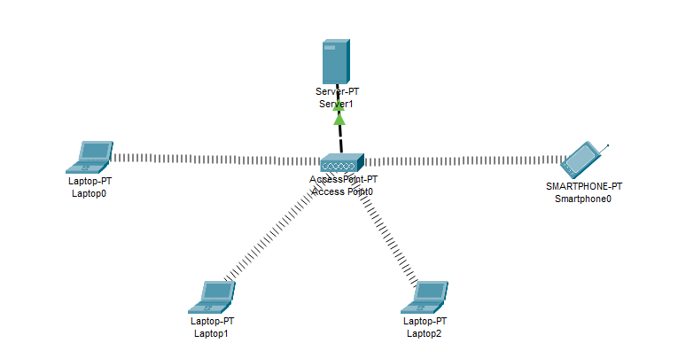

Take all devices.

**server:**

Assign ip add to server 192.168.0.1 .

In services create pool of address,

name : pool 1

default gate way : 192.168.0.1

Ip starts from : 192.168.0.2

subnet mask : 255.255.255.0

maximum no. of user : 10

save.

**Connect server to access point.**

**Laptop:**

Go to physical add wireless module,

off the laptop.

add

WPC300N

on the laptop.

assign ip through dhcp.

**smartphone automatically connected to AP.**

**Check the connectivity of Laptops & Smartphone by ping or sending massages.**

**1.1 Static Routing:**

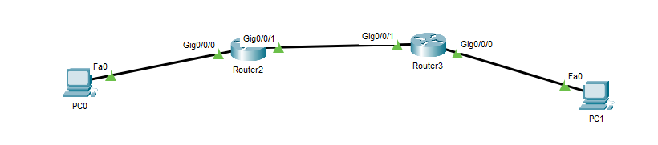

**Specification:**

N/w1 192.168.1.0

N/w2 192.168.2.0

between two routers N/w 10.10.10.0

PC0 192.168.1.2

PC1 192.168.2.2

g0/0/0 192.168.1.1

g0/0/0 192.168 2.1

g0/0/1 10.10.10.1

g0/0/1 10.10.10.2

**Commands:**

**Router 2:**

en

conf t

int g0/0/0

ip add 192.168.1.1 255.255.255.0

no sh

ex

int g0/0/1

ip add 10.10.10.1 255.255.255.0

no sh

ip route 192.168.2.0 255.255.255.0 10.10.10.2

**Router 3:**

en

conf t

int g0/0/0

ip add 192.168.2.1 255.255.255.0

no sh

ex

int g0/0/1

ip add 10.10.10.2 255.255.255.0

no sh

ip route 192.168.1.0 255.255.255.0 10.10.10.1

**1.2 static routing:**

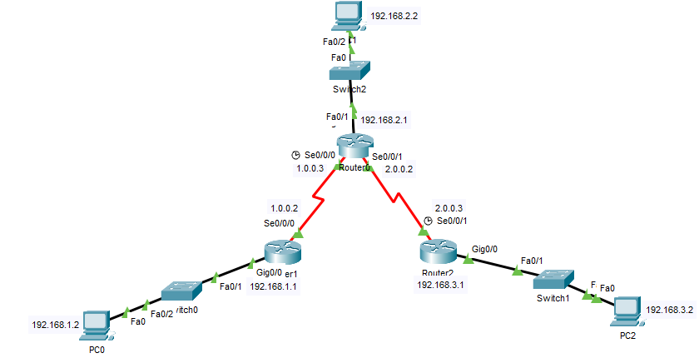

**Specification :**

PC0 IP 192.168.1.2 Gate way 192.168.1.1

PC1 IP 192.168.2.2 Gate way 192.168.2.1

PC2 IP 192.168.3.2 Gate way 192.168.3.1

R0 N/w ID 1.0.0.3 and 2.0.0.2

R1 N/w ID 1.0.0.2

R2 N/w ID 2.0.0.3

**Commands:**

First configure the IP and default gate-way on computers.

**Router 0 :**

en

conf t

int g0/0

ip add 192.168.2.1 255.255.255.0

no sh

ex

int s0/0/0

ip add 1.0.0.3 255.255.255.0

no sh

ex

int s0/0/1

ip add 2.0.0.2 255.255.255.0

no sh

ex

ip route 192.168.1.0 255.255.255.0 1.0.0.2

ip route 192.168.3.0 255.255.255.0 2.0.0.3

**Router 1 :**

en

conf t

int g0/0

ip add 192.168.1.1 255.255.255.0

no sh

ex

int s0/0/0

ip add 1.0.0.2 255.255.255.0

no sh

ex

ip route 192.168.2.0 255.255.255.0 1.0.0.3

ip route 192.168.3.0 255.255.255.0 1.0.0.3

ip route 2.0.0.0 255.255.255.0 1.0.0.3

**Router 2 :**

en

conf t

int g0/0

ip add 192.168.3.1 255.255.255.0

no sh

ex

int s0/0/0

ip add 2.0.0.3 255.255.255.0

no sh

ex

ip route 192.168.1.0 255.255.255.0 2.0.0.2

ip route 192.168.2.0 255.255.255.0 2.0.0.2

ip route 1.0.0.0 255.255.255.0 2.0.0.2

**Standard-ACL:**

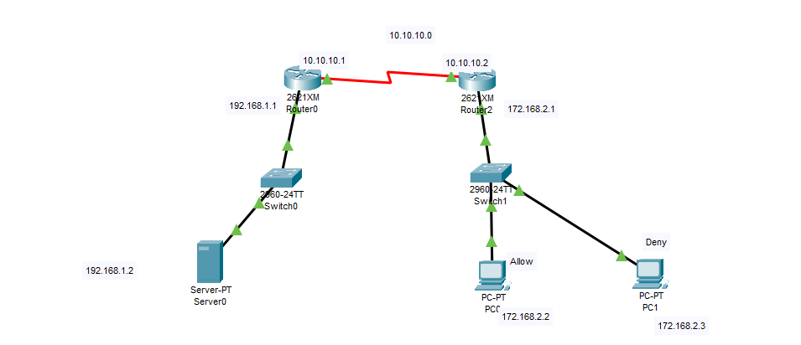

**Router 0,**

en

conf t

int f0/0

ip add 192.168.1.1 255.255.255.0

no sh

int s0/0

ip add 10.10.10.1 255.255.255.0

no sh

router rip

net 10.10.10.0

net 192.168.1.0

**Router 1,**

en

conf t

int f0/0

ip add 172.168.2.1 255.255.0.0

no sh

int s0/0

ip add 10.10.10.2 255.255.255.0

no sh

router rip

net 10.10.10.0

net 172.168.2.0

ex

access-list 14 deny host 172.168.2.3

access-list 14 permit any

int s0/0

ip access-group 14 out

int f0/0

ip access-group 14 in

ex

ex

show access-list 14

do ping from allow and deny pc to server and verify the configuration.

**Single area OSPF:**

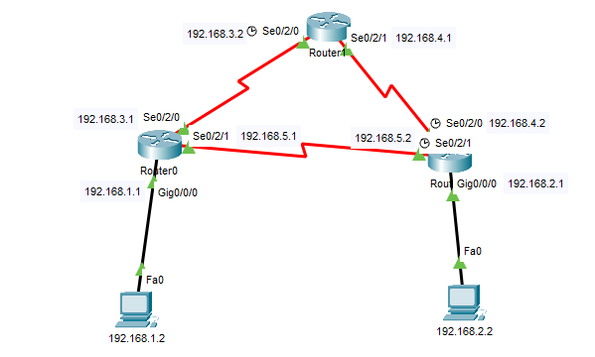

**Router 0 :**

en

conf t

int g0/0/0

ip add 192.168.1.1 255.255.255.0

no sh

ex

int s0/2/0

ip add 192.168.3.1 255.255.255.0

no sh

ex

int s0/2/1

ip add 192.168.5.1 255.255.255.0

no sh

ex

router ospf 1

network 192.168.1.0 0.0.0.255 area 0

network 192.168.3.0 0.0.0.255 area 0

network 192.168.5.0 0.0.0.255 area 0

ex

ex

wr

**Router 1 :**

en

conf t

int s0/2/0

ip add 192.168.3.2 255.255.255.0

no sh

ex

int s0/2/1

ip add 192.168.4.1 255.255.255.0

no sh

ex

router ospf 1

network 192.168.3.0 0.0.0.255 area 0

network 192.168.4.0 0.0.0.255 area 0

ex

ex

wr

**Router 2 :**

en

conf t

int g0/0/0

ip add 192.168.2.1 255.255.255.0

no sh

ex

int s0/2/0

ip add 192.168.4.2 255.255.255.0

no sh

ex

int s0/2/1

ip add 192.168.5.2 255.255.255.0

no sh

ex

router ospf 1

network 192.168.2.0 0.0.0.255 area 0

network 192.168.4.0 0.0.0.255 area 0

network 192.168.5.0 0.0.0.255 area 0

ex

ex

wr

**Standard-ACL:**

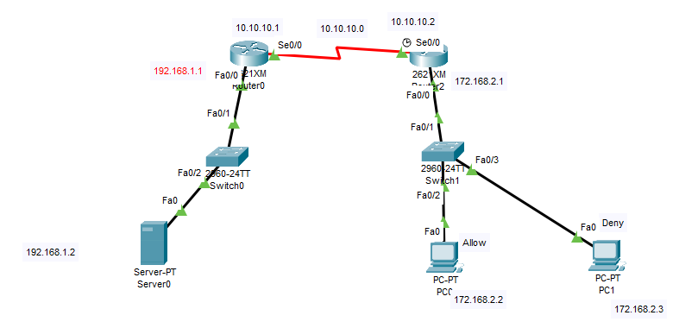

**Router 0,**

en

conf t

int f0/0

ip add 192.168.1.1 255.255.255.0

no sh

int s0/0

ip add 10.10.10.1 255.255.255.0

no sh

router rip

net 10.10.10.0

net 192.168.1.0

**Router 1,**

en

conf t

int f0/0

ip add 172.168.2.1 255.255.0.0

no sh

int s0/0

ip add 10.10.10.2 255.255.255.0

no sh

router rip

net 10.10.10.0

net 172.168.2.0

ex

access-list 14 deny host 172.168.2.3

access-list 14 permit any

int s0/0

ip access-group 14 out

int f0/0

ip access-group 14 in

ex

ex

show access-list 14

do ping from allow and deny pc to server and verify the configuration.

**Extended-ACL (using http server):**

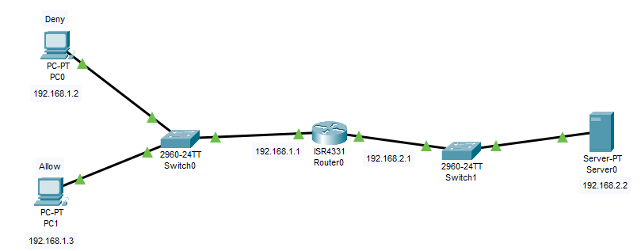

PC0 : 192.168.1.2 DGW : 192.168.1.1

PC1 : 192.168.1.3 DGW : 192.168.1.1

Server : 192.168.2.2 DGW: 192.168.2.1

**Router 0,**

en

conf t

int g0/0/0

ip add 192.168.2.1 255.255.255.0

no sh

int g0/0/1

ip add 192.168.1.1 255.255.255.0

no sh

ex

access-list 120 deny tcp host 192.168.1.2 host 192.168.2.2 eq 80

access-list 120 permit to ip any any

int g0/0/1

ip access-group 120 in

end

To verify,

Go to pc0, desktop, web browser, 192.168.2.2

Not showing the result due to deny permission for host 192.168.1.2

Go to pc1, desktop, web browser, 192.168.2.2

Showing the result due to permit permission for host 192.168.1.3